Megan Banaski – Lab 6 – CIS 120

Test Plan:

leafCount- empty tree, tree with one element, tree with multiple elements, complete tree, unevenly distributed tree.

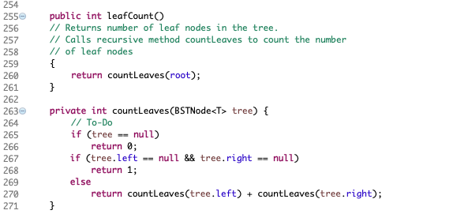

singleParentCount- empty tree, tree with one element, tree with multiple elements, complete tree, unevenly distributed tree.

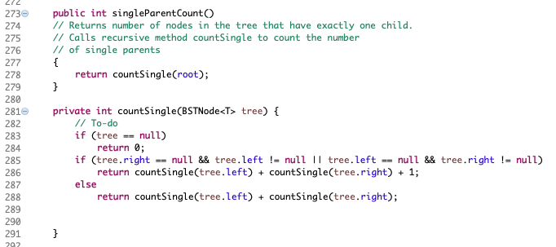

Tree that I’m testing with: 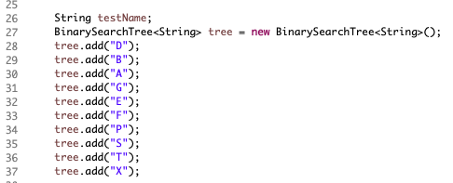

leafCount test:

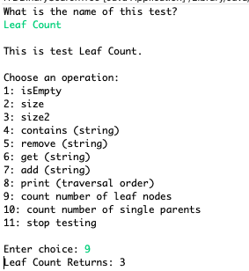

Single Parent Test:

